Richard Gibbens: In Memoriam
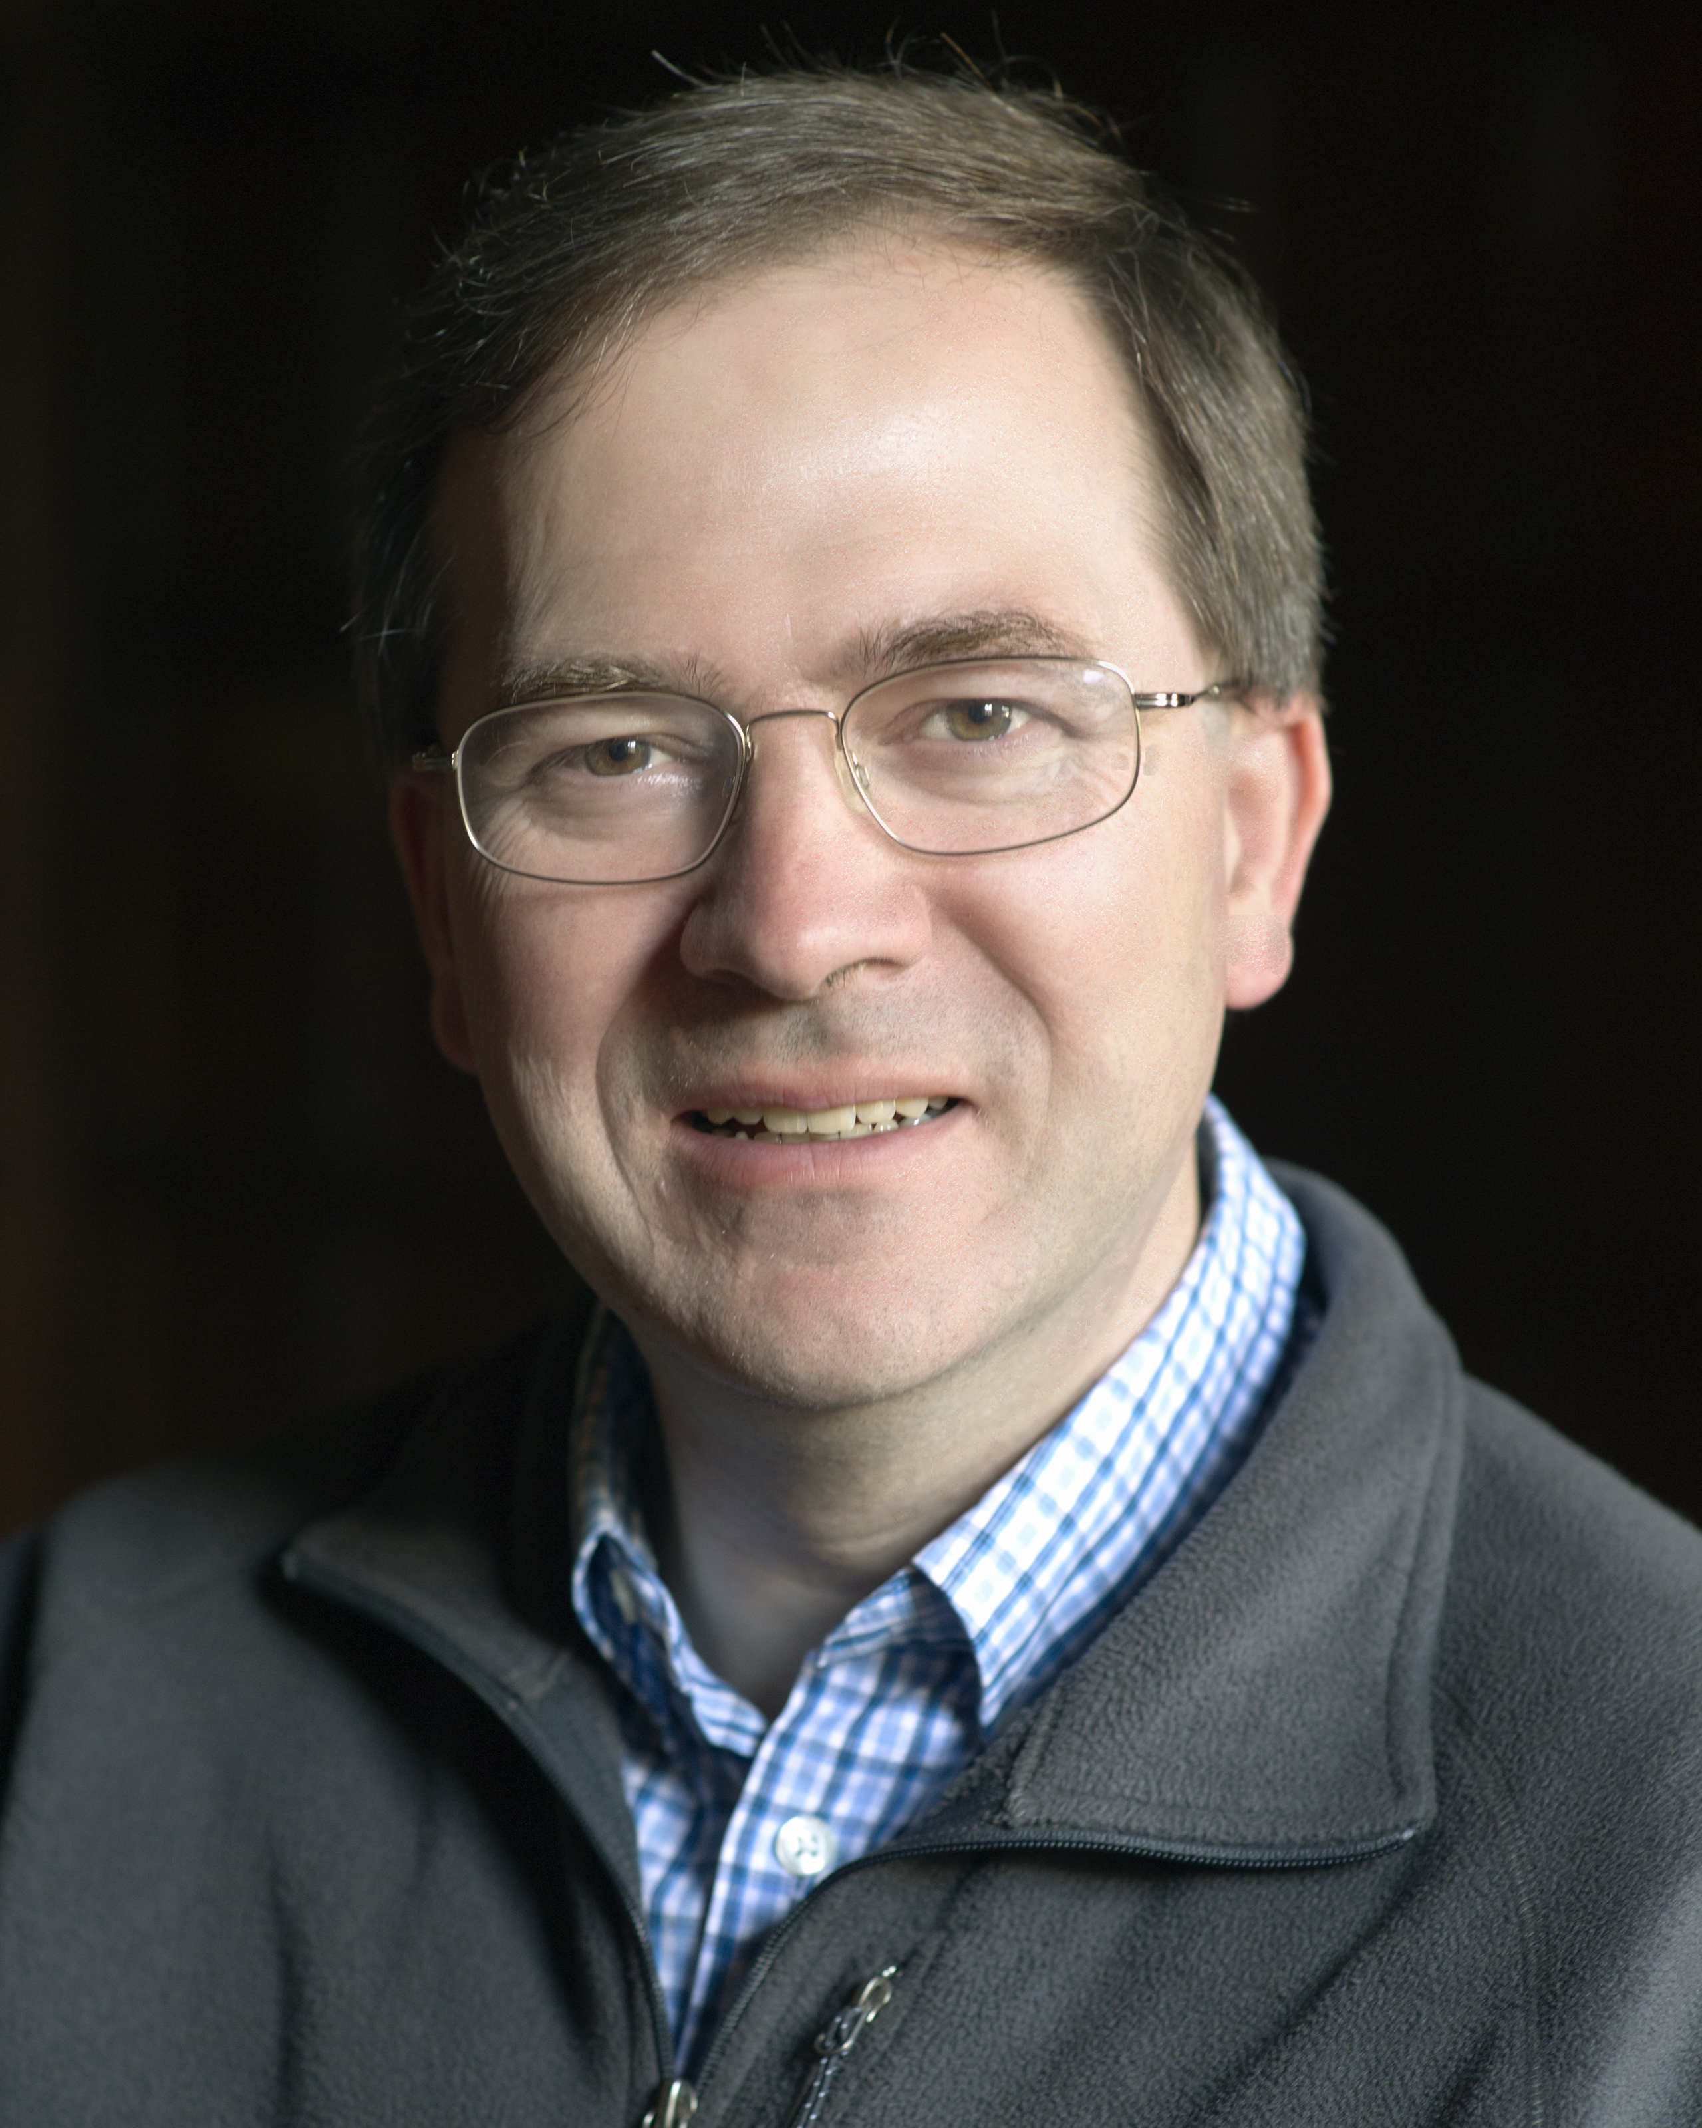
Richard J. Gibbens passed away on 12 August 2018 after a short illness, aged 56. He was Reader in Network Modelling in the Computer Laboratory of the University of Cambridge, and was due to become the Professor of Network Modelling in October 2018. He was Program co-Chair and co-edited the Proceedings of the IFIP Performance 2013 Conference, and a member of the TPC for Performance 2018.
Richard came to Cambridge as a mathematics undergraduate in 1980 and received his PhD in 1988. His doctoral thesis, on Dynamic Alternative Routing (DAR), was based on work performed with David Songhurst and Peter Key at British Telecom's Laboratories at Martlesham and with Frank Kelly in Cambridge. DAR provided a call-routing procedure in telephone networks for choosing alternative call paths when the primary path between a source and destination was blocked; the work was presented at the 12th International Teletraffic Congress (ITC) in Turin in 1988. Key to the success of DAR was the ability to determine the alternative paths online and in real time with limited information. DAR’s success led to implementation in the British Telecom network and Richard’s work attracted international attention.
There followed a postdoctoral year at Bell Labs, in the Mathematics of Networks and Systems Research Department led by Debasis Mitra, when his interests included state-dependent routing, a topic of importance to AT&T’s network at that time. Richard made lifelong friends during his stay, and it left him with a lasting love for the United States. His period at Bell Labs was a formative influence on Richard’s work, an example being his later important paper with Phil Hunt on effective bandwidths on the multi-type uniform arrival and service channel. European collaborations were also valued by Richard, and he was an active contributor to several EU sponsored programmes. Richard was a pioneer of work on measurement-based distributed admission control for packet networks and incentive mechanisms within and between congested networks.
In 1993 Richard was awarded a prestigious Royal Society University Research Fellowship. Richard was an early example of what we would now call a data scientist. In the Statistical Laboratory in Cambridge during the 1990s he was a tireless early advocate of first S-plus and then the R programming language for data analysis in research and teaching. It was natural when the Alan Turing Institute, with its focus on data science and artificial intelligence, was founded in 2015 that Richard should be one of its first Turing Fellows.
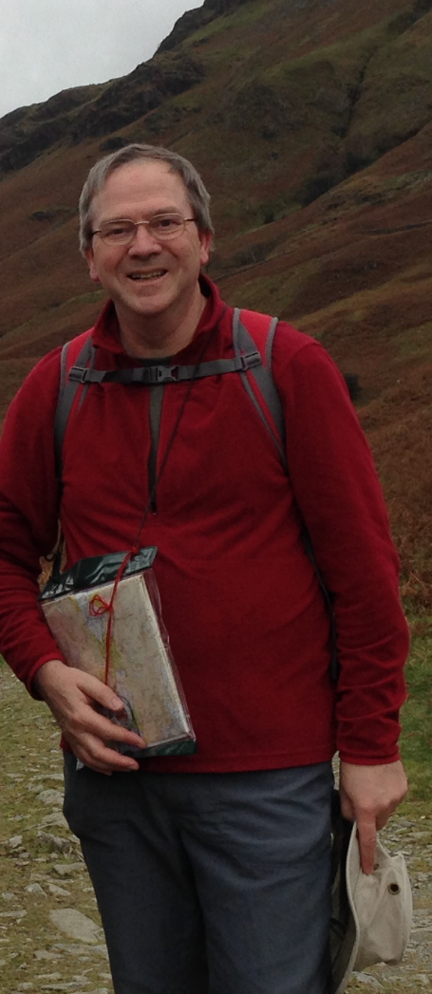
Richard became a University Lecturer in the Computer Laboratory and a Fellow of Gonville and Caius College, Cambridge, in 2001. His research interests extended from communication networks to road transport networks and energy networks. He developed algorithms to predict journey times on road networks from a fusing of historic and real-time data, and for the optimal control of large-scale electricity storage. Most recently he was, with Don Towsley, working on an International Technology Alliance between the US Army Research Laboratory and the UK Ministry of Defence on distributed analytics and information science, and an Alan Turing Institute project on modelling the effects on distribution grids of the recharging of electric vehicles. Richard published over 70 papers and held six patents.

Richard collaborated widely with researchers around the world, and it has been striking to see the international reaction to his passing. He was a gentle and kind soul, modest and unassuming; the best of friends for many of us; generous and hospitable, delighted to share an ingenious new way of doing something. He had, as some of his American friends in particular have noted, a wonderfully dry sense of humour.

Richard’s loss is felt deeply by all who knew him, but especially by his wife Helen and their two teenage children. He was a wonderful husband and father, much loved by his family, and found great enjoyment in spending time with them. It is of some consolation for them to know that Richard was so well-respected and esteemed by fellow researchers around the world. He made many influential scientific contributions but will also be fondly remembered for his exceptional kindness and gentle demeanour.

Frank Kelly, Debasis Mitra and Ilze Ziedins

